Data Collection and Understanding
Public dataset selection, structure, quality profile, and modeling readiness

Dataset | Predict Students' Dropout and Academic Success
Repository | UCI Machine Learning Repository
License | Creative Commons Attribution 4.0 International (CC BY 4.0)
Scale | 4,424 student records; 36 predictors; 1 target

The selected UCI dataset is suitable for this capstone because it directly supports student-outcome prediction, is publicly accessible under a permissive attribution license, contains a meaningful number of observations, combines demographic, socioeconomic, enrollment, and academic variables, and provides a three-class target: Dropout, Enrolled, and Graduate.
The dataset contains no machine-readable missing values, blank strings, or exact duplicate rows. However, data understanding cannot stop at null counts: most categorical fields are stored as integer codes, some occupation fields use code 99 for blank or unknown, the source column name 'Nacionality' is misspelled, and six second-semester variables are unavailable at the intended first-semester prediction point. These issues are handled explicitly in the reproducible pipeline.

1. Source and provenance
Item | Detail
Repository record | UCI dataset ID 697; DOI 10.24432/C5MC89
Creators | Valentim Realinho, Mónica Vieira Martins, Jorge Machado, and Luís Baptista
Created / updated | Created 2021; UCI record updated 26 February 2024
Institutional context | Students enrolled in undergraduate programs at one Portuguese higher-education institution
Official missing-value flag | No
Reuse condition | CC BY 4.0: attribution to the source is required

Official source: UCI Machine Learning Repository dataset page

2. Dataset structure and target
Characteristic | Observed value | Interpretation
Rows | 4,424 | One record per student.
Columns | 37 | 36 predictors plus one target.
Categorical features | 17 | Integer-coded categories; must not be treated as continuous quantities.
Discrete numeric features | 12 | Counts or bounded integer measures.
Continuous numeric features | 7 | Grades and macroeconomic indicators.
Primary early-warning candidates | 30 | Available by the end of the first semester.
Excluded for timing | 6 | Second-semester measures that would leak future information.

Target distribution
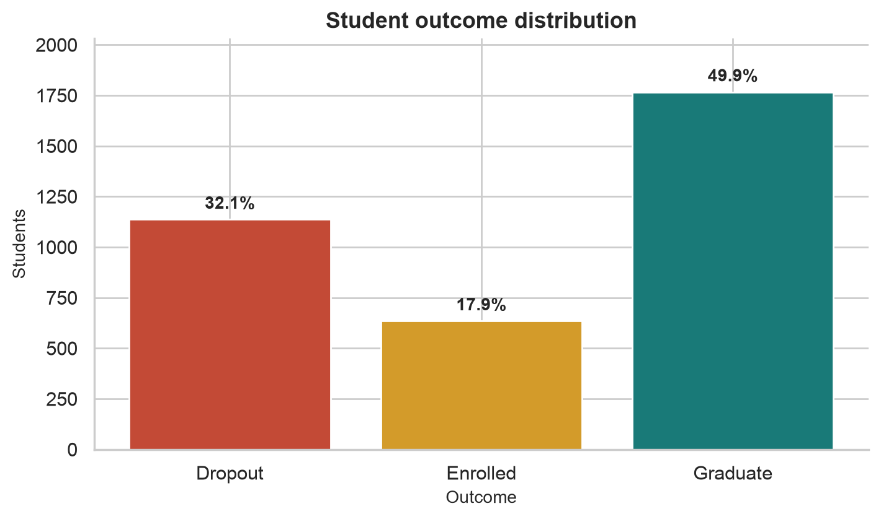
Figure 1. Outcome distribution in the 4,424-record dataset.
Outcome | Count | Share
Graduate | 2,209 | 49.93%
Dropout | 1,421 | 32.12%
Enrolled | 794 | 17.95%

The target is moderately imbalanced rather than extremely rare. Stratified train/test splitting and class-aware evaluation are still required, with particular attention to Dropout recall and precision.

3. Feature timing and role
The raw variables span enrollment context, prior education, socioeconomic background, first- and second-semester performance, and macroeconomic context. Feature availability is evaluated against the Task 1 decision point.
Feature family | Examples | Primary-model treatment
Application and program | Application mode/order, course, attendance | Retain if available before enrollment or at semester close.
Prior education | Previous qualification, prior grade, admission grade | Retain; encode categorical codes separately from numeric grades.
Demographic and household | Age, marital status, parental education/occupation | Audit for sensitivity and proxy effects before inclusion.
Financial status | Scholarship, debtor, tuition fees up to date | Retain with fairness review and careful interpretation.
First-semester academics | Units enrolled, evaluated, approved, grade, credited, no evaluations | Retain; these are central signals at the prediction point.
Second-semester academics | Corresponding six second-semester variables | Exclude from the primary early-warning model to prevent leakage.
Macroeconomic context | Unemployment, inflation, GDP | Retain as numeric context; monitor drift when moving across years or regions.

Why this dataset was chosen
- Strong problem fit: the target directly matches dropout and academic-success outcomes.
- Operational relevance: first-semester academic signals allow a realistic early-warning use case.
- Analytical richness: mixed feature types support preprocessing, feature engineering, explainability, and fairness analysis.
- Adequate scale: 4,424 records provide enough cases for stratified model comparison while remaining reproducible on a personal computer.
- Transparent provenance: UCI provides formal metadata, variable descriptions, a DOI, named creators, and an open license.
- Capstone completeness: the data supports EDA, multiclass modeling, threshold/capacity analysis, subgroup audit, and stakeholder communication.

4. Data quality assessment
Check | Finding | Decision
Machine-readable nulls | 0 across all columns | No numeric or categorical imputation is required for the supplied file.
Blank strings | 0 | No whitespace-based missing values were detected.
Exact duplicates | 0 rows | No duplicate removal is required.
Semantic missingness | Occupation code 99 denotes blank/unknown | Treat the documented code as an explicit category, not a numeric magnitude.
Column naming | Source uses 'Nacionality' | Standardize to 'Nationality' in processed data and preserve the mapping.
Integer-coded categories | 17 features | Use categorical preprocessing; do not imply an ordinal distance unless documented.
Outlier flags | IQR rules flag values in several numeric fields | Use flags as review prompts; retain values that are valid under source definitions.
Information leakage | 6 second-semester predictors | Remove from the first-semester model before splitting and training.

Outlier interpretation
Statistical rarity does not automatically imply bad data. Variables such as age at enrollment, credited course units, or macroeconomic indicators may contain legitimate extremes. The project therefore records IQR-based flags, checks each field against its documented meaning and observed support, and avoids deleting valid students solely because their values are uncommon.

Reproducible handling rules
- Preserve an unchanged raw CSV and the downloaded UCI metadata as source evidence.
- Normalize only documented naming issues and record the transformation.
- Assign semantic types before preprocessing so category codes are not treated as measurements.
- Exclude second-semester variables from the primary early-warning feature set; then fit encoders, scalers, and models on training data only using stratified splits.

5. Data dictionary
The companion workbook, Task 2 Dataset Overview and Dictionary.xlsx, is the authoritative 37-variable dictionary submitted with this report. It records each variable's role, official type, semantic type, availability stage, primary-model use, fairness role, units, official description, observed values, and missing-value count. The summary below explains its organization.
Dictionary field | Purpose
Variable and role | Identifies each of the 36 predictors and the Target column.
Official type | Preserves the data type reported by UCI.
Semantic type | Distinguishes coded categories from discrete and continuous numeric measures.
Stage available | Shows whether the field is known at enrollment, first semester, or second semester.
Primary model use | Documents inclusion, exclusion, or audit-first treatment.
Fairness role | Flags potential sensitive attributes or proxy variables for later audit.
Official description | Retains source meanings and categorical code labels.
Observed values and missingness | Provides empirical support and data-quality evidence from the downloaded CSV.

Representative variables
Variable | Semantic type | Availability | Role in early-warning model
Age at enrollment | Discrete numeric | Enrollment | Candidate; audit subgroup effects
Tuition fees up to date | Categorical/binary | Enrollment and administration | Candidate; fairness review
Curricular units 1st sem (approved) | Discrete numeric | End of first semester | Candidate academic signal
Curricular units 2nd sem (grade) | Continuous numeric | End of second semester | Excluded for prediction timing
Target | Categorical outcome | Observed later | Prediction label: Dropout, Enrolled, Graduate

6. Limitations and readiness conclusion
- The data comes from one Portuguese institution; results may not transfer to another place, program mix, or time period.
- Administrative variables can encode structural disadvantage; predictive value alone does not justify student-facing use.
- The dataset supports prediction, not causal claims about which intervention will prevent dropout.
- Enrolled is an interim state, so outcome definitions and evaluation windows must align to local policy before deployment.
Conclusion: the dataset is fit for a capstone proof of concept, but deployment requires local validation, governance approval, prospective monitoring, and a controlled evaluation of the support program.

References
UCI Machine Learning Repository. Predict Students' Dropout and Academic Success. DOI: 10.24432/C5MC89. CC BY 4.0.
Martins, M. V., Tolledo, D., Machado, J., Baptista, L. M. T., and Realinho, V. (2021). Early prediction of student's performance in higher education: a case study. Trends and Applications in Information Systems and Technologies.

